English

In English, we will focus on Writing to Inform by creating a letter in role, recounting events from the story ‘Coming to England’ by Floella Benjamin. We will explore how to structure recounts, use time connectives, and develop our descriptive language.

Science

In Science, we will explore rocks, learning about different types, their properties and how they are formed. Children will carry out practical investigations to develop their scientific enquiry skills.
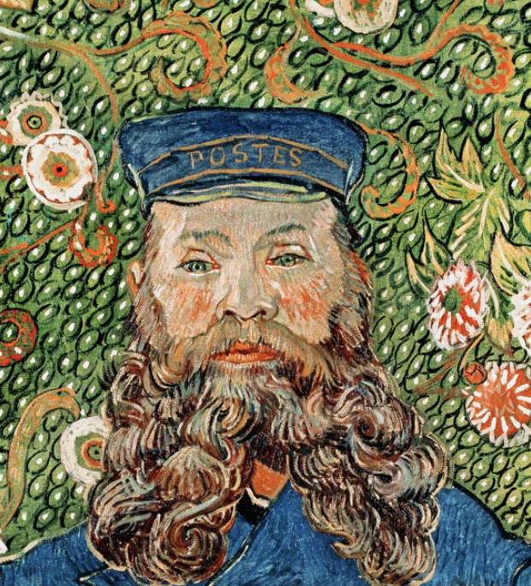

Maths

In Maths, children will begin with place value, developing their understanding of number size and representation. We will then move onto addition and subtraction, consolidating mental and written strategies.
Art

In Art, we will begin with Drawing and Painting focusing on techniques for line, texture, colour mixing and shading.
History

In History, we will explore the Stone Age to Iron Age period, learning about early human life, tools, homes and how communities developed.

PE

In PE, we will develop our fundamental skills such as balancing, running and landing jumps. We will also be developing our ball skills while throwing and catching.

PSHE

In PSHE, we will explore British Values and complete the ‘Keeping/Staying Safe’ unit, covering road, water, medicine and stranger safety.
RE

In RE, we will explore ‘What do Christians learn from the Creation story?’, discussing the importance of creation for Christians and how it influences their lives.

§

Music
In Music we will be learning about Ballads. We will discuss different stylistic features of different genres, styles and traditions of music. We will also be describing the timbre, dynamic and textual details of a piece of music.

Computing

In Computing, we will start with our unit on Online Safety, learning how to stay safe online, protect personal information and understand digital footprints.
Geography

In Geography, we will be discussing Fieldwork and will explore compass points to show direction.

Dig Deeper – Learn at home by:
Reading  - Read at least four times a week with your child. | Watching  - BBC Bitesize clips on the Stone Age to Iron Age  - Short documentaries on rocks and fossils
Doing  - Use Times Table Rockstars 2 times a week for 5 minutes. | Talking  - About how to stay safe online and what rules you should follow to keep safe.

