English

We will be reading Meesha Makes Friends by Tom Percival and exploring the characters, feelings and events in the story. We will use the text to help us write diary entries, imagining what a character might think, feel and experience.

Science

We will become scientists and investigate the different types of animals, including humans. We will compare similarities and differences between animals as well as look at what food different animals eat. We will understand the terms herbivore, omnivore and carnivore and investigate the different senses we have as humans.

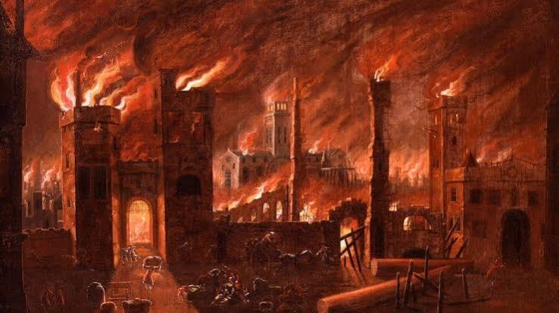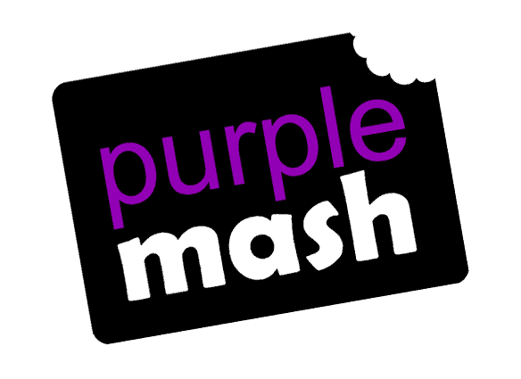

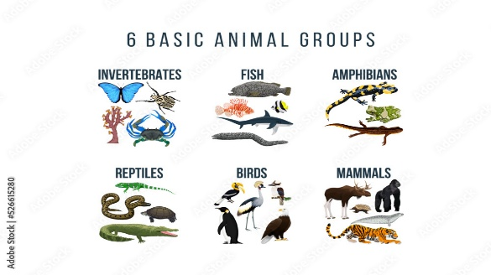

Maths

We will develop our understanding of place value by counting forwards and backwards, reading and writing numbers, finding 1 more and 1 less, using number lines and hundred squares, estimating, comparing and ordering numbers. Year 2 will extend this learning to larger numbers and solve word problems.

Art

We will develop our drawing skills by exploring different materials and techniques. Children will learn how to use lines, shapes and patterns to create artwork and begin to draw with increasing control and detail.

Humanities

In history, We will be learning about the Great Fire of London and how it changed the city. We will explore what happened during the fire, learn about key people and events, and discover how we know about the past.

In Geography, we will be learning about the human and physical features of our local area. We will explore what makes our area special and learn how people and the environment shape the places where we live.

PE
We will develop our sending and receiving skills through a variety of target games, learning how to aim, control objects and work as part of a team. We will also develop our fundamental movement skills and create dance sequences by copying, repeating and linking actions together.

PSHE
We will learn how to stay safe online and in everyday situations, build positive relationships, understand bullying and body language, explore British Values, and learn how to speak up and stay safe.

RE
We will be learning about Islam and how Muslims live. We will be exploring what is important to Muslims and what Muslims believe about God. We will learn about special places, beliefs and celebrations, and how faith influences daily life.

Music
We will be learning about pulse and beat through listening, singing and movement activities. We will explore keeping a steady pulse, identifying the beat in music and using instruments and our bodies to respond to different rhythms.

Phonics
We will develop our reading and writing skills through the Little Wandle phonics programme. Year 1 will revisit Phases 3 and 4 before learning Phase 5. Year 2 will revisit and consolidate Phase 5 to support fluent reading and writing.
Computing

We will be learning all about how to stay safe online.

Dig Deeper – Learn at home by:
Reading  - Reading your reading book every day as well as books you enjoy reading to explore new story language. | Watching  - Numberblocks.  - Nature programmes
Doing  - What animals can you see when you are out and can you work out what type of animal they are and what diet they eat? | Talking  - About how to stay safe online and what rules you should follow to keep safe.

