John Wilkinson Primary School and Nursery

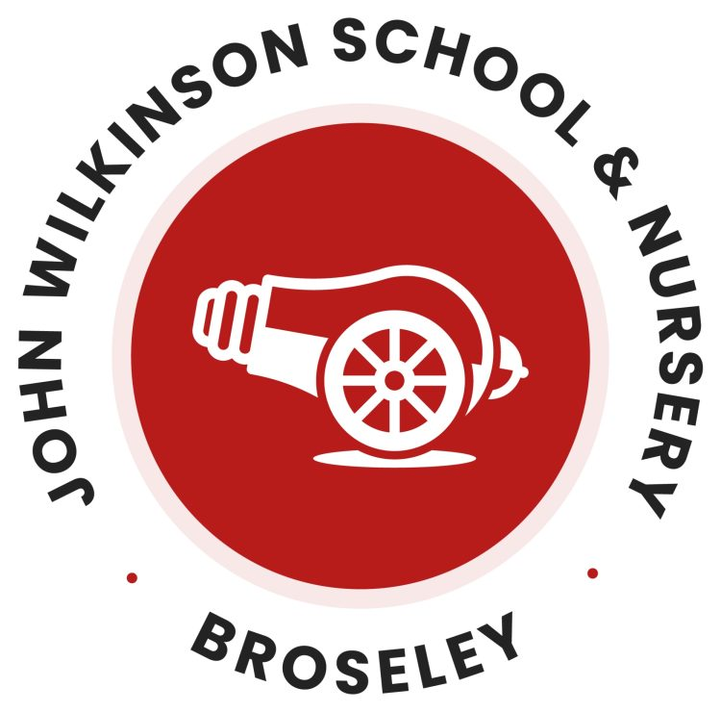

Phonics and Early Reading Policy

Written by: Emily Otto
Date: September 2026
Review: September 2027

Introduction

At John Wilkinson Primary School, we are committed to ensuring that all children develop the knowledge, skills and confidence to become fluent, lifelong readers and to foster a genuine love of reading. We believe in Quality First Teaching that is engaging, inclusive and purposeful, with enthusiastic delivery, active participation, appropriate challenge, consistent routines and effective praise.

At John Wilkinson, we use Little Wandle Letters and Sounds Revised as our chosen systematic synthetic phonics (SSP) programme. This provides a structured, high-quality approach to the teaching of early reading, phonics and spelling. Through fidelity to the programme and a consistent approach across the school, children are taught to use their phonic knowledge confidently and independently as the primary strategy for reading unfamiliar words.

What is Systematic Synthetic Phonics?

Systematic Synthetic Phonics (SSP) is an approach to teaching early reading and spelling that enables children to develop the skills needed to decode and encode words confidently.

Children are taught to:

- Recognise the relationship between sounds (phonemes) and the letters or groups of letters (graphemes) that represent them.
- Read words by identifying the graphemes, saying the corresponding phonemes and blending them together to hear and say the word.
- Spell words by segmenting them into individual phonemes and selecting the correct graphemes to represent each sound.
- Apply their phonic knowledge to read and spell unfamiliar words with increasing accuracy and fluency.

Through daily phonics teaching, children develop secure decoding skills, enabling them to become confident, fluent readers and writers.

What is the Little Wandle Letters and Sounds Revised Approach?

Little Wandle Letters and Sounds Revised is a complete systematic synthetic phonics programme (SSP) designed to teach children to read, write and spell with confidence and accuracy. The programme is based on the science of reading and draws upon research into how children learn most effectively.

At John Wilkinson Primary School, we teach phonics through Little Wandle Letters and Sounds Revised. The programme provides a clear progression of phonological awareness, grapheme-phoneme correspondences (GPCs), blending and segmenting skills, enabling children to develop secure foundations for reading and writing.
Little Wandle follows the key principles of effective learning. Lessons are carefully structured to ensure:
- Focused attention through short, daily phonics sessions.
- Active engagement through high levels of participation and oral rehearsal.
- Immediate and positive error correction to secure accurate learning.
- Regular practice and consolidation to build fluency and long-term retention.
Children are taught to apply their phonics knowledge by blending sounds to read words and segmenting words to spell. New learning is revisited regularly, and opportunities for revision and consolidation are built into the programme to ensure knowledge becomes secure.

In Reception and KS1, additional reading practice sessions are closely matched to each child's current phonic knowledge using fully decodable books. This allows children to practise and apply the sounds they have been taught, helping them to develop accuracy, automaticity and fluency as readers. Reading practice sessions focus on three key areas:
- Decoding
- Prosody (reading with expression)
- Comprehension

Alongside the teaching of phonics, we recognise that reading is more than word recognition alone. We place equal importance on developing children's language, vocabulary and comprehension skills, as well as fostering a love of reading through high-quality texts, story time and reading for pleasure opportunities.

Through high-quality teaching, consistent routines and commitment to the Little Wandle programme, we aim to ensure that every child becomes a confident, successful reader, regardless of their starting point or background.

Terminology

Pure Sounds – pronouncing each letter sound clearly and distinctly without adding additional sounds to end e.g. ‘f’ not ‘fuh’.

Grapheme – A letter (or sequence of letters) that represent a phoneme.

Phoneme – The smallest unit of sound in a word – often referred to as ‘a sound’.

Grapheme Phoneme Correspondence (GPC) – The match between a phoneme and a grapheme.

Blending – Putting together the individual sounds in a word to make a word.

Segmenting – Breaking words or parts of words into its phonemes.
Sound Buttons – Visual symbols placed underneath graphemes to support blending and decoding. Dots are used under single-letter sounds and lines are used under digraphs and trigraphs.

Tricky Word – A word containing a part that cannot yet be decoded using the phonic knowledge children have been taught. These words are taught explicitly.

Multi-Syllabic word – A word with more that one syllable.

Diagraph – A phoneme that is represented by two letters.

Trigraph – A phoneme that is represented by three letters.

Split diagraph – A diagraph that is separated by one or more consonants within a word e.g. make.

Adjacent consonant – Consonants blended together when reading a word.

Alternative grapheme – Different representations of a phoneme in a word.

Fluency – The ability to read accurately, at an appropriate pace, and with expression.

Prosody – Reading with expression, rhythm and intonation that reflects meaning.

Lesson Structure and Sequence

Little Wandle is designed as a whole-class Systematic Synthetic Phonics programme for children in Nursery, Reception and Key Stage 1. Daily 20-30 minute discrete phonics sessions are delivered by trained teaching staff. We teach phonics for 30 minutes a day.

In Reception, we build from 10-minute lessons, with additional daily oral blending games, to full-length lessons as quickly as possible. Each Friday, we review the week’s teaching to help children become fluent readers. Children make a strong start in Reception: teaching begins in week 2 of the Autumn term.

We follow the Little Wandle Letters and Sounds Revised expectations of progress:
- Children in Reception are taught to read and spell words using Phase 2 and 3 GPCs, and words with adjacent consonants (Phase 4) with fluency and accuracy.
- Children in Year 1 review Phases 3 and 4 and are taught to read and spell words using Phase 5 GPCs with fluency and accuracy.
- Children in Year 2, when ready, progress to the bridge to spelling and spelling units.

Little Wandle uses a three-part lesson structure in Key Stage 1 which ensures children become familiar with the format of the sessions, allowing the entirety of lesson time to be focused on teaching and learning, not transitioning between activities.

Revisit and Review:

- Review GPCs
- Revisit decodable words
- Revisit tricky words
- Introduce new tricky word of the day

Teach and Practise:

- Introduce new grapheme, spelling pattern or HFW.
- Hook and engage learning through shuffle time/song/book or video.
- Practise oral blending and decoding.

Application:

- Read/Write a sentence with focus sound/spelling pattern.
- Independent spelling practice.

How do we teach Phonics at John Wilkinson Primary School?

Revisit and Review

Staff will revisit and review as follows:

Reception
- The teacher begins by recapping a selection of large grapheme flash cards, revisiting tracing the letter and saying the sound using ‘my turn, our turn, your turn’.
- The teacher then uses small flash cards to quickly do a ‘speedy sounds’ retrieval.
Year 1

- The teacher uses a selection of small flash cards to do a ‘speedy sounds’ retrieval task, encouraging the children to say the sound as soon as possible. We encourage the children to say the sounds ‘short and sharp.’
- After this, the teacher then revisits a selection of key words from the previous session, encouraging children to read the words fluently and if necessary, use the sound button side of the flashcard to remember. There will also be a few tricky words included to practice.

Teach and Practise – Blending to Read

Staff will introduce the sound and practice blending to read as follows:

Reception

- Orally teach the new sound of the day. Use ‘my turn, our turn, your turn’ to say the sound.
- Using ‘what’s in the box’, show images or objects that begin with the corresponding phoneme. Choose children to say the word and use my turn, our turn, your turn to reinforce.
- Show the large flash card with the picture side first. Trace your finger over the grapheme with the visual, whilst saying the sound e.g. ‘h, h, helicopter’ and then ask the children to repeat. Turn the card around to show the grapheme on it’s own and repeat several times.
- The children will then practice blending to read key words of the day. Teachers initially model blending using a clear 'sound button' approach, where children say each phoneme before sweeping across the word to blend and read it fluently. They learn that dots represent single sounds and dashes represent digraphs/trigraphs. As children become more confident, they move from overt sounding out to reading words automatically.

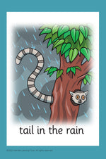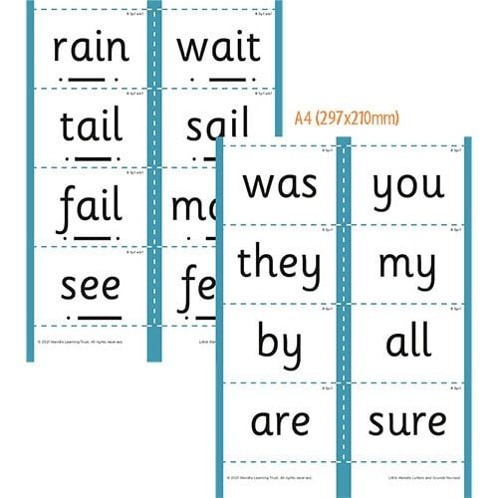

Year 1

- Show the grapheme card and say the sound clearly, short and sharp several times. Use my turn, our turn, your turn to say the sound.
- Follow the ‘phoneme spotter’ and ‘shuffle time’ strategies to reinforce learning. The grapheme card is mixed in a small pile of other sounds and the children put their hands on their heads when they spot today’s sound.
- The children will then practice blending to read key words of the day. Teachers initially model blending using a clear 'sound button' approach, where children say each phoneme before sweeping across the word to blend and read it fluently. They learn that dots represent single sounds and dashes represent digraphs/trigraphs. As children become more confident, they move from overt sounding out to reading words automatically.

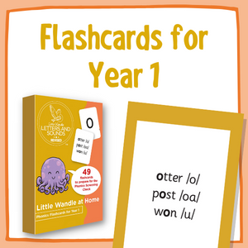

N.B - Alongside the sound action cards, there are a lot of additional resources relating to each new sound which help engage the children and reinforce their knowledge such as:
- Get squiggling
- Geraldine the Giraffe

Application – Segmenting to Spell

Reception

In Reception, children are taught to hear, identify and count the sounds in simple words before matching those sounds to graphemes (letters or groups of letters). As they learn new grapheme-phoneme correspondences, they practise segmenting words orally and then applying this knowledge in writing activities.
Teachers model the process by saying a word, identifying each phoneme, and encouraging children to 'robot talk' the word, for example:
- cat → /c/ /a/ /t/
- ship → /sh/ /i/ /p/

Children use resources such as phoneme frames and letter cards to support them in breaking words into sounds before selecting the correct graphemes to represent each phoneme. As their knowledge grows through Phases 2, 3 and 4, they progress from spelling simple CVC words to words containing digraphs, adjacent consonants, longer words and compound words, to short sentences.

In Reception, children first take part in a 'Read a Sentence' activity, where they read a sentence containing previously taught grapheme-phoneme correspondences and tricky words. The teacher then models how to orally rehearse and segment words from the sentence before writing them.

Children are encouraged to:
- Say the sentence aloud.
- Count the words in the sentence.
- Segment each word into its individual phonemes.
- Identify the grapheme that represents each sound.
- Write the word before rereading the sentence to check it makes sense.

For example, when writing the sentence, "The cat sat on the mat," children would orally segment cat into /c/ /a/ /t/ and identify the corresponding graphemes before recording the word. This process helps children make the link between reading and spelling while embedding their knowledge of newly taught sounds.

Year 1

In Year 1 the children build on the segmenting skills established in Reception. They revisit and review previously taught grapheme-phoneme correspondences while learning additional Phase 5 alternative spellings and pronunciations.
Children are taught to segment increasingly complex words, including those containing:
- alternative graphemes for known phonemes
- longer multisyllabic words
- prefixes and suffixes
- words with adjacent consonants and more complex spelling patterns

When spelling, pupils are encouraged to say the word, segment it into phonemes, identify the correct grapheme for each sound, and then write the word. They learn that some phonemes can be represented in different ways and are supported in choosing the most appropriate spelling based on their phonic knowledge.

In Year 1, the sentence writing activity builds on the foundations established in Reception. Children continue to read a sentence before writing it, but the words become increasingly complex as they learn alternative spellings for phonemes and more sophisticated spelling patterns.

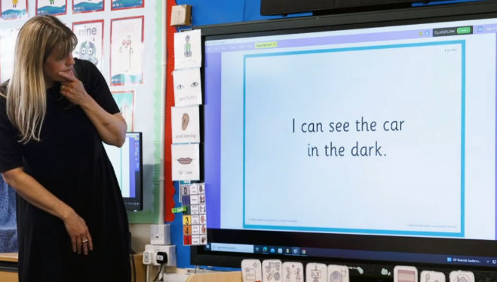
During the 'Write a Sentence' activity, pupils are expected to:
- Hold a sentence in their memory.
- Identify each word within the sentence.
- Segment words into phonemes accurately.
- Select the correct grapheme from a range of possible spellings.
- Apply spelling conventions, punctuation and capital letters.

The teacher supports children in using their phonics knowledge to make spelling choices, encouraging them to think carefully about which grapheme best represents each sound.
Teaching High Frequency Words (HFW)/ Common Exception Words (CEW)

In Little Wandle Letters and Sounds Revised, children are taught tricky words and high-frequency words alongside their daily phonics lessons. Tricky words are words that contain graphemes that have not yet been taught or do not fully follow the phonics patterns children know. Teachers explicitly identify the 'tricky' part of the word and help children practise reading and spelling it until it becomes familiar. High-frequency words that can be decoded are taught through children's growing phonic knowledge, ensuring that pupils continue to apply their blending and segmenting skills rather than relying on memorisation alone.

New words are introduced systematically, revisited regularly, and practised through word reading, sentence reading, dictation and decodable reading books. This approach ensures that children build a secure sight vocabulary while still developing strong decoding and spelling strategies for both reading and writing.

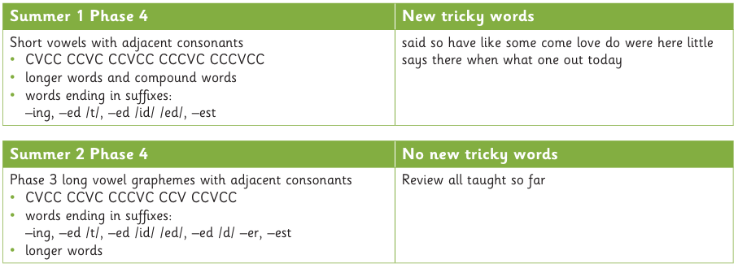
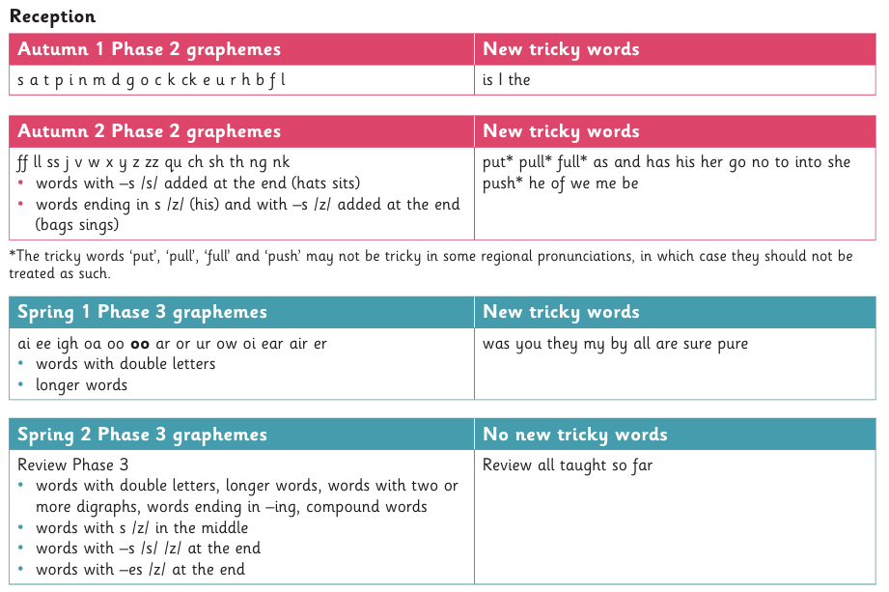
Progression Overview

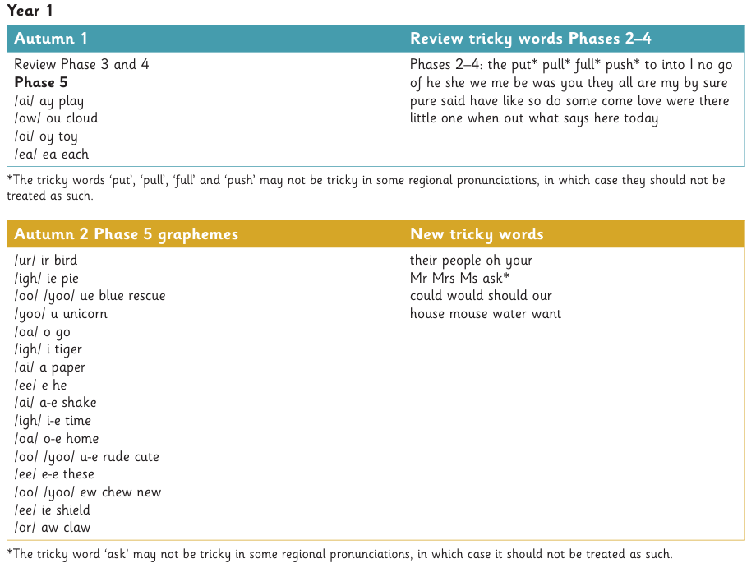

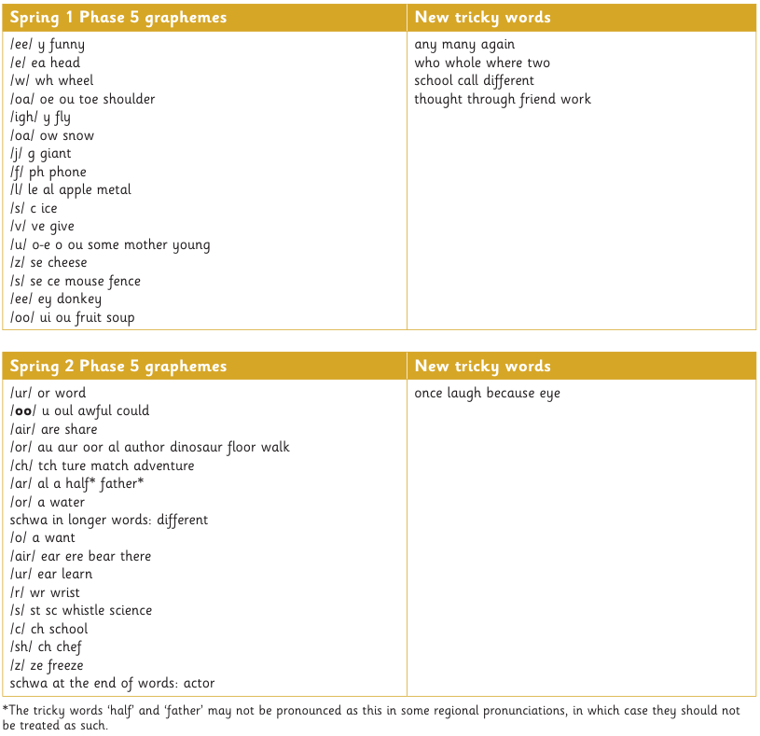

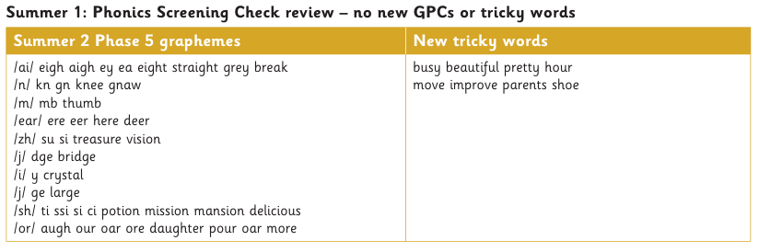
Interventions

We embed Little Wandle interventions within our phonics and early reading provision, ensuring that all children receive the support they need to make progress and that gaps in learning are identified and addressed promptly. There are three main programmes we use:

Daily Keep-up Programme

The daily keep-up programme provides immediate, targeted support for children who are at risk of falling behind in phonics. Delivered through short, focused sessions, it revisits the specific grapheme-phoneme correspondences, blending or segmenting skills that were not fully secured during the main lesson. The aim is to help children quickly keep up with their peers, preventing gaps in learning from developing and ensuring they can continue to access age-related phonics teaching.

Rapid Catch-up Programme

The Rapid Catch-up programme is designed for older pupils who have not yet secured the essential phonic knowledge and decoding skills needed for fluent reading. Through systematic and intensive teaching, pupils revisit key grapheme-phoneme correspondences and practise blending and reading with increasing accuracy and fluency. The programme aims to rapidly close gaps in reading development, enabling pupils to become confident readers who can successfully access the wider curriculum.

SEND Intervention Programme

SEND phonics interventions provide personalised support for pupils with special educational needs and disabilities who require additional teaching beyond whole-class phonics lessons and keep-up sessions. Sessions are carefully adapted to meet individual needs, using repetition, multi-sensory strategies, overlearning and smaller learning steps to help pupils secure phonics knowledge, decoding and encoding skills. The aim is to ensure that every child makes progress from their individual starting point and develops the reading skills needed for future success.

How staff use this intervention

- Children are identified as ‘at risk of not keeping up’. This will include any children who have not met one or more of the learning objectives of the recent lesson plan (as shown in the Termly Planning) and children who have gaps in learning shown in the regular assessments.
- Teachers will use the Little Wandle flowcharts to identify skills gaps.
- Teachers will select the intervention focus, using the flowcharts to help find the correct one.
- Intervention will take place for 5 weeks, recording these on the intervention record sheets to show progress and impact.
- Teachers will reassess the children and record progress. For children who have still not met the Learning Objectives, liaise with the Phonics Lead to create a suitable catch-up plan – this may require a separate intervention group to the Keep-Up groups.

Steps to becoming a lifelong reader at John Wilkinson Primary School and Nursery

All children will have:

- Daily Phonics lessons
- Daily whole-class story book reading
- 3 x weekly guided reading sessions
- Individual weekly reading with a decodable book at their assessed level

“Spotlight children” will also have:
- Keep up phonics sessions (intervention) through either:
- Little Wandle Daily Keep-up
- SEN Programme
- Rapid Catch up programme
- Individual daily reading with a decodable book at their assessed level, alongside speedy sound practice to begin each daily reading session
- Phonics flashcards sent home for further support

All teachers are responsible for ensuring that this provision takes place in their classroom. Oversight is had from SLT, English and Phonics Lead to monitor the provision, progress and impact.

Displays and Resources

Resources used throughout EYFS and KS1 are consistent to ensure that all children are able to access them. Little Wandle sound and word mats are available in all classrooms during all lessons. Each year group ensures that the resources available are in line with the progress documents.

Each class has a phonics display that details the sounds taught so far, the focus of the week – including sound and High Frequence Word focus, words that contain the sounds taught that week and any previously taught graphemes (in line with the progression overview).

Written application work is recorded in phonics books with the date clearly labelled.

Assessment

Summative Assessment

Regular and efficient monitoring of children’s development in phonics is essential if they are to become competent and confident readers, and subsequently writers. The Little Wandle programme has a clearly mapped set of termly assessments which allows for checking children’s grapheme-phoneme correspondence (GPC) knowledge, knowledge of High Frequency Words (HFWs) and Common Exception Words (CEWs) for reading and writing.

The assessment schedule for Little Wandle is broken down for each year group. Each year group has a set of graphemes, CEWs and HFWs to be learned and then assessed.

Additional mock phonics screening check assessments take place in Year 1 in the lead up to the Phonics Screening Check. These assessments take place 1:1 with an adult.

Daily Formative Assessment

The first and most frequently used assessment will take place daily by the adults delivering the phonics session. It is suggested that children who have not met the daily objective, as stated in the planning document for the lesson, are noted and any gaps are addressed with a short recap at some point for the next phonics lesson. If this form of assessment is followed thoroughly, children should be getting the best possible provision in order that gaps in learning do no occur, or at best, very infrequently. Each weekly plan has a planning assessment box for teachers to use to assess children daily.

As with any formative assessment, teachers should also be regularly reviewing the children’s achievements in the application of newly taught skills and knowledge. In the case of phonics, this is applicable in the area of reading and writing throughout the rest of the curriculum (independent, guided or 1:1). Again, this allows for any misconceptions or problems to be quickly identified and work to be planned to fill potential gaps.

Spelling Assessment

Spelling assessment is done through daily formative assessment during the application stage of a phonics lesson. Summative spelling assessments are done in addition, for those children who are ready to write. They are in the form of simple dictation, although may also be given as individual words. These assessments take place after Phase 2, in the middle and end of Phase 3, at the end of phase 4 and in the middle and end of phase 5. Children can use magnetic letters, a whiteboard or iPad to write the words if needed. Individual record sheets allow the spelling of each word to be recorded.
The Progression of Little Wandle Decodable Books

Little Wandle decodable books are carefully matched to the phonics knowledge that children have been taught, ensuring that they can successfully apply their decoding skills when reading.

In Reception, children begin with books containing simple words that use the grapheme-phoneme correspondences they have recently learned. As their phonics knowledge develops through Phases 2, 3 and 4, books gradually introduce a wider range of sounds, tricky words and increasingly complex word structures.

In Year 1, children continue to read fully decodable texts that reflect their growing understanding of Phase 5 phonics, including alternative spellings and pronunciations. The progression of books is designed to build accuracy, fluency and confidence, allowing children to move from reading with support to reading independently. Through regular reading practice sessions, children develop automatic word recognition, improved comprehension and a love of reading, ensuring they are well prepared to transition from learning to read to reading to learn.

In Year 2, children who have successfully completed the Little Wandle phonics programme move on from fully decodable books to a wider range of age-appropriate reading materials. The emphasis is on developing reading fluency, prosody and comprehension, enabling pupils to read accurately, at an appropriate pace and with expression. Children who still require support with decoding continue to access Little Wandle decodable books and targeted interventions to ensure that gaps in phonic knowledge are addressed. This approach ensures that all pupils read books closely matched to their current stage of reading development while continuing to build confidence, stamina and a love of reading.

Reading Scheme Structure

Reception Books

Reception books support the teaching of initial sounds and consonant digraphs to help the fundamental stages of reading. The familiar characters and fun stories engage children in reading. Each Reception book has a section for an adults to use to help support them at the back of each book.

Foundation 1 – Wordless books
Phase 2 (sets 1-4) – Focus on blending the letters and the consonant digraphs.
Phase 3 (sets 1-4) – Practises digraphs and trigraphs.
Phase 4 (sets 1-4) – Practices reading words with adjacent consonants e.g. CVCC, CCVC, CCVCC and CCCVC.

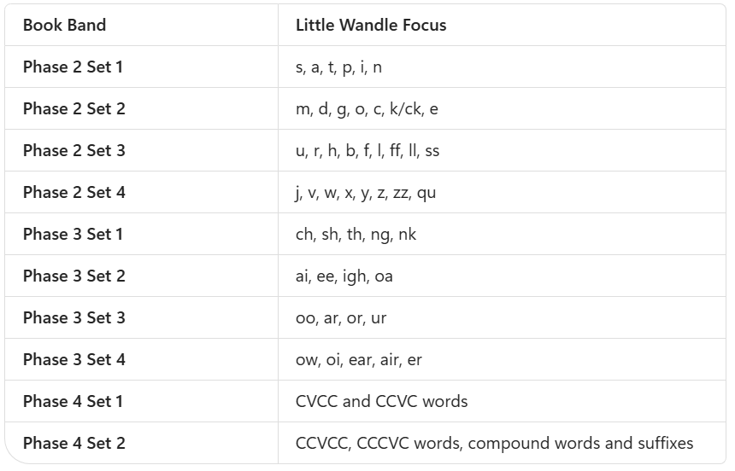

Year 1 Books

Stories are matched to the Year 1 graphemes in the KS1 curriculum.

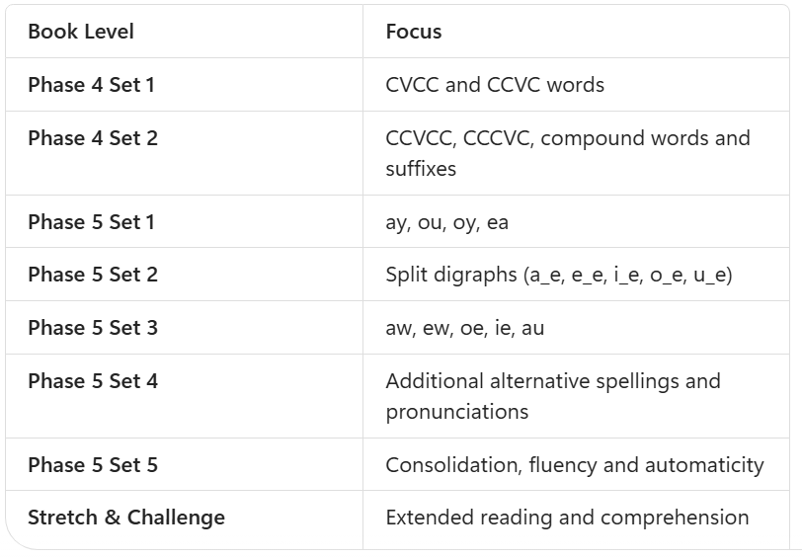

Year 2 Books

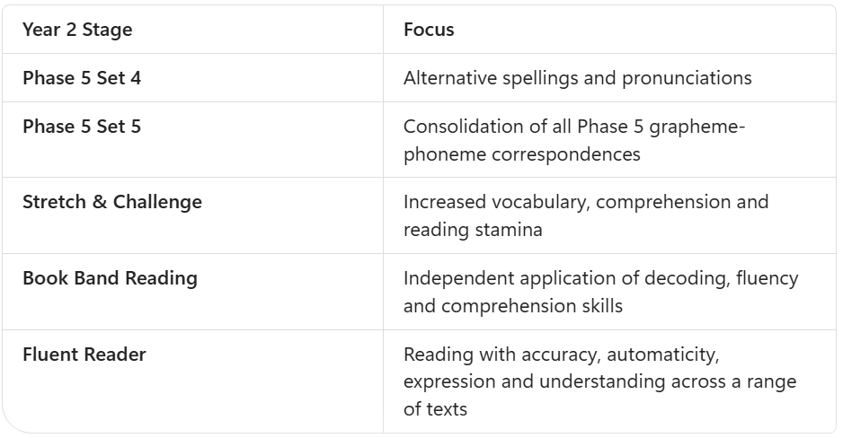
In Year 2, pupils continue to access Little Wandle decodable books until they have securely mastered all Phase 5 grapheme-phoneme correspondences and can read accurately, fluently and with confidence. Once children have graduated from the Little Wandle reading programme, they transition to our structured book band scheme and the John Murray Reading Explorers programme. The focus moves beyond decoding and towards developing fluency, vocabulary, comprehension, inference and discussion skills. This ensures that pupils continue to build reading stamina and deepen their understanding of increasingly complex texts whilst fostering a lifelong love of reading.

Book Structure

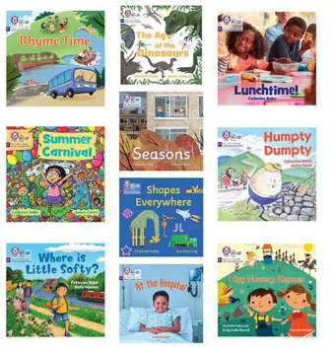
Little Wandle books feature engaging stories, appealing illustrations and age-appropriate content that develop confidence, fluency and a love of reading. In the earliest Reception books, additional text is provided for an adult to read aloud. This text enriches the story, develops vocabulary and comprehension, and models fluent reading without requiring children to decode words beyond their taught phonic knowledge .

Before reading, children revisit key graphemes, tricky words and vocabulary that appear within the text, helping them to approach the book with confidence. As children progress through the Little Wandle programme, books gradually increase in length, complexity and challenge, while remaining fully decodable and closely matched to the phonics progression. Reading practice follows the Little Wandle three-read model, allowing children to develop decoding accuracy, reading fluency, prosody and comprehension through repeated reading. Opportunities for discussion throughout the books encourage children to develop their vocabulary, inference and understanding of what they have read, supporting their journey from learning to read to reading for meaning and enjoyment.
Placement Procedure for Little Wandle Reading Books

Children are assessed regularly to identify their secure phonic knowledge and decoding abilities. Assessment outcomes are used alongside the Little Wandle matching guidance to place each child on the most appropriate reading book level. Books are carefully matched to the grapheme-phoneme correspondences (GPCs) and tricky words that children can read confidently, ensuring that they can successfully decode and read with accuracy. Children should not be given books containing phonics knowledge that has not yet been taught.

Following each assessment point, teachers group pupils according to their reading stage and allocate a decodable book that matches their secure phonic knowledge. Children who are making rapid progress may move to the next book level between assessments, provided they can read the graphemes, practice words and tricky words fluently. Pupils who are not yet secure receive additional support through Daily Keep-up sessions and are reassessed more frequently to ensure their book level reflects their progress.

To confirm that a book is appropriately matched, children should be able to:
- Read the graphemes in the book confidently.
- Read the practice words with accuracy and increasing fluency.
- Recognise and read the tricky words.
- Read the text with a high level of success and understanding.
This careful matching process ensures that every child experiences success in reading, develops fluency and confidence, and progresses through the Little Wandle reading programme at an appropriate pace.

Guided Reading

Reception

Staff use the results of the placement procedure (detailed above) to allocate children with a similar level of phonics knowledge to a guided reading group. Guided reading groups may be uneven in size and can be updated throughout the year to reflect the assessment as children progress at different rates.

At John Wilkinson Primary, we believe that Guided Reading helps children to practise their reading at an appropriate level in a structured situation with support if required, teaching the explicit skills required to become fluent and confident readers. Guided Reading is taught 3 times a week for 20 minutes. Each session is recorded in the child’s reading record. The same book is read in each session to help children practise fluency.

Session focus:

Monday – Session 1 – Grapheme recognition, decoding and blending skills
Tuesday – Session 2 – Prosody (expression)
Wednesday – Session 3 – Comprehension

Year 1 and 2

Alongside phonics and decodable reading practice, pupils in Years 1 and 2 take part in daily whole-class reading sessions based around carefully selected, high-quality texts. These sessions are designed to develop language comprehension, vocabulary acquisition and reading for pleasure by exposing children to texts that may be beyond their current independent reading ability.

Through teacher modelling, discussion and structured questioning, pupils develop key comprehension skills, including prediction, retrieval, vocabulary exploration and inference. This approach enables all children to access the same rich texts, broadens their literary experiences and nurtures enthusiastic, lifelong readers.

Home Reading

At the end of the week, a decodable phonics book matched carefully to the child’s ability and sound focus that week is sent home. In addition to this, our children take home a range of resources to support their phonics skills and Early Reading. This includes:

- A Little Wandle decodable book.
- A library book for reading for pleasure.
- Sound flashcards (Reception).
- HFW/CEW flashcards (Reception).
- A Sound and Word Mat (Year 1 and 2).
- A word list with decodable words linked to that weeks sound focus.

Reading for Pleasure

Daily Stories and Story Time

Reading aloud is a valued part of daily life throughout the school. In Reception, children enjoy are read to several times a day, where they are introduced to a wide range of high-quality picture books, traditional tales, poetry and non-fiction texts. These sessions help to develop children's language, vocabulary, comprehension and understanding of the world, whilst fostering a love of books and reading from an early age.

In Years 1 and 2, children continue to participate in daily story time sessions. Teachers share carefully selected, high-quality texts that expose pupils to rich vocabulary, varied authors and diverse experiences. Through listening, discussion and book talk, children develop their comprehension skills, deepen their understanding of language and literature, and cultivate positive attitudes towards reading. These sessions provide opportunities for children to enjoy stories beyond their independent reading level and help nurture a lifelong love of reading.

Each classroom from Nursery-Year 2 has an inspiring book corner for the children to access books for pleasure and foster a love of reading.
Poetry, Song and Rhyme

Poetry, songs and rhymes are an important part of our reading culture and are enjoyed regularly across the school. Through listening to, learning and performing poems and rhymes, children develop their vocabulary, speaking and listening skills, confidence and appreciation of language. We believe that poetry should be shared, celebrated and enjoyed by all children.

To encourage families to share reading together, children participate in our Poetry Club. Each week, a child takes home a poetry book and a special teddy to enjoy with their family. Families are encouraged to read poems aloud, revisit favourites and talk about the language and imagery they encounter. This shared experience helps to promote reading for pleasure, strengthens home-school links and fosters a lifelong love of words, stories and poetry.

Phonics in Nursery

When children begin their Nursery year, they start their early phonics journey through the Little Wandle Foundations for Phonics programme. Foundations for Phonics is designed to develop children's speaking and listening skills, language development and phonological awareness, providing the foundations needed for successful phonics learning in Reception. Through high-quality adult interactions, carefully planned activities and opportunities for language-rich play, children learn to tune into sounds, listen carefully and explore how sounds can be used in words and sentences.

The programme is based on the principles of Phase 1 phonics and focuses on developing children's awareness of sounds before introducing grapheme-phoneme correspondences. Children take part in daily activities that encourage them to discriminate between sounds, recognise patterns in language and build confidence in using and speaking new vocabulary.

The seven key aspects of Phase 1 are:
- Environmental sounds
- Instrumental sounds
- Body percussion
- Rhythm and rhyme
- Alliteration
- Voice sounds
- Oral blending and segmenting

Across these aspects, children learn to:

- Tune into sounds and develop auditory discrimination
- Listen to, remember and sequence sounds
- Talk about sounds and develop vocabulary and language comprehension

Throughout the year, children engage in regular opportunities to sing songs, join in with rhymes, listen to stories, explore sounds in the environment and play games that develop oral blending and segmenting skills. These experiences build strong foundations for reading and writing and prepare children for the systematic teaching of phonics when they begin the Little Wandle programme in Reception.

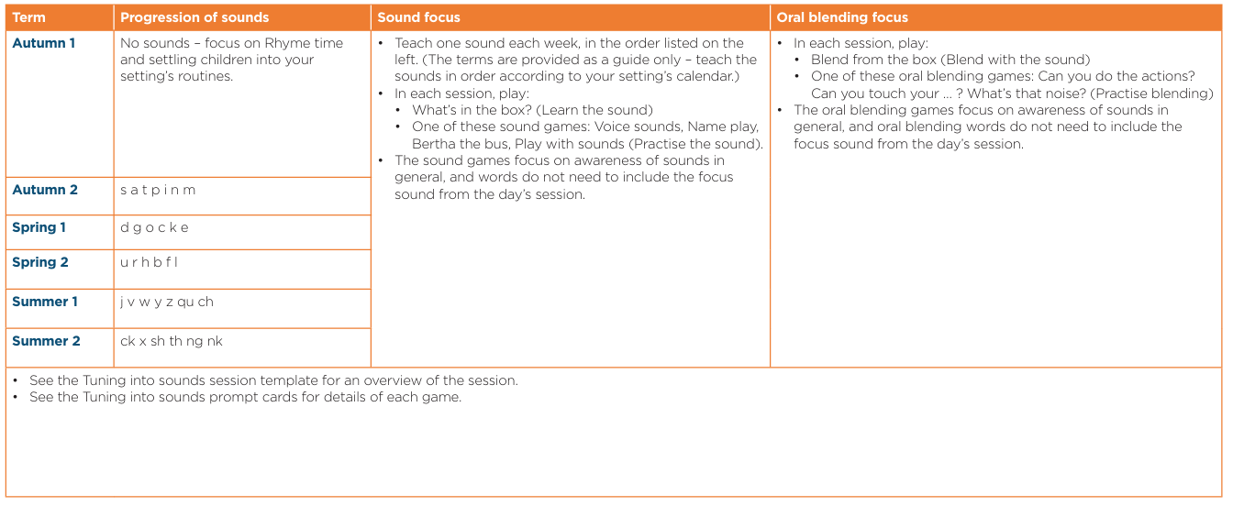

Conclusion

We believe that reading is the key to unlocking the wider curriculum and lifelong learning. Through the effective implementation of Little Wandle Letters and Sounds Revised, high-quality reading provision and early intervention, we strive to ensure that every child becomes a confident, fluent and enthusiastic reader who is prepared for the next stage of their educational journey.

